Minutes of the Meeting of the
Middlesex County Master Gardener Focus Group
April 29, 2011
In attendance: Peggy Becker, Jamie Burgess, John Carlson, Cherry Czuba, Marsha Dowling, Marisa Fede, Susan Logatto, Fern Martin, Chantal Foster, Maureen Gillis, along with Interns Susan Allison, Tad Bartles, Lois Bukowiec, Sherry Van Liere, Tom Kalal, Karen Rottner and Jim Woodworth – welcome to the new additions!

Thanks to Marsha for a wonderful spread! Everything was delicious! Also thanks to Jamie for the delectable desserts. Just what we all needed, no doubt.

Minutes have been posted to http://mcmgcg.weebly.com/

Financials:
Maureen indicated we have had a $200 increase to our balance -- $150 from Russell Library for the outreach program held there earlier in the month and a $50 donation from the Middlesex County Extension Council in memory of Jackie Fantasia. Maureen sent a thank you card in recognition of the donation on Jackie’s behalf. These funds will come in handy for some upcoming expenses for the planting season (vent opener, plants/seeds, etc.). As always, we gladly accept donations, most recently from Fern for bean and chard seeds and Marsha for the lovely herb tags – thanks!

Old Business:
- Russell Library Outreach – well received by the audience, good experience for the group. John has issues with the parking, however! The $150 was a nice bonus. Thanks to all who participated.
- Open the Garden on April 16 was a real success, thanks to all who participated!
- We are in need of a stirrup hoe – ours has either been taken home inadvertently by one of us or otherwise taken. Chantal will search her tools to see if she was the culprit, and if not, purchase a new one as this is a much utilized tool in the garden. There was some discussion around the need for a lock on the shed, but it was decided this was not necessary.

New Business:
- Spinach Harvesting: Thanks to our Trusty Interns for monitoring the spinach crop. Chaleen harvested 17.5 pounds of the green stuff this week and delivered to AG. A calendar was passed around for the next harvests, and we are covered! The next donation will be brought to SVDP. Maureen has restocked the bags for delivery of the spinach. If you have extra plastic bags, please remember to bring a few when you come to harvest.
- Garden Plan: Paul and Sandy’s Too has offered us the 48 tomato plants we need. Fern will pick these up for planting day and also purchase the 36 eggplant we need. Chantal will purchase the various pepper varieties from Gotta’s along with some bulk bean seeds from Hart’s. The remaining seeds needed will be supplied by Jamie. See Maureen’s spreadsheet with the varieties.
- Sign for Garden: Great suggestion to have a sign which acknowledges businesses who have donated supplies to the garden. Maureen and Chantal will work up something suitable for posting.
- Prep the Garden Date – Sunday, May 15 at 9:00: Spinach should be history by this time. This is the next opportunity to work together as a group setting up the soaker systems, tomato stakes, cucumber supports as well as familiarizing Interns with the garden.
- May 28 – Planting Date at 10:00 a.m. (rain date May 29): This is a great experience! Plan to bring newspaper as all rows are mulched with wet newspaper covered in Mainely Mulch. Refreshments to be provided.
- Herb Garden – John suggested add some herbs to achieve a well-rounded “kitchen herb garden” and has sent out a list with this information. Marisa and Susan A. have offered to work on this project. There were many offers for chives, and Tad offered “as much basil as we could use”. It was noted that certain herbs should be planted inside the fence due to the deer issue.
- Pear Tree – a brief discussion regarding spraying of the pear tree. It was agreed we would not spray this year, just wait and see. The tree looks beautiful with its blossoms.

As our Planting Day is May 28, there will not be a May meeting. Next meeting is Friday, June 24 at 6:30 pm.

Meeting ended at 7:50 pm but we stood around chatting until after 8! It was a pleasure to see so many people admiring the garden. It sure does look lovely!

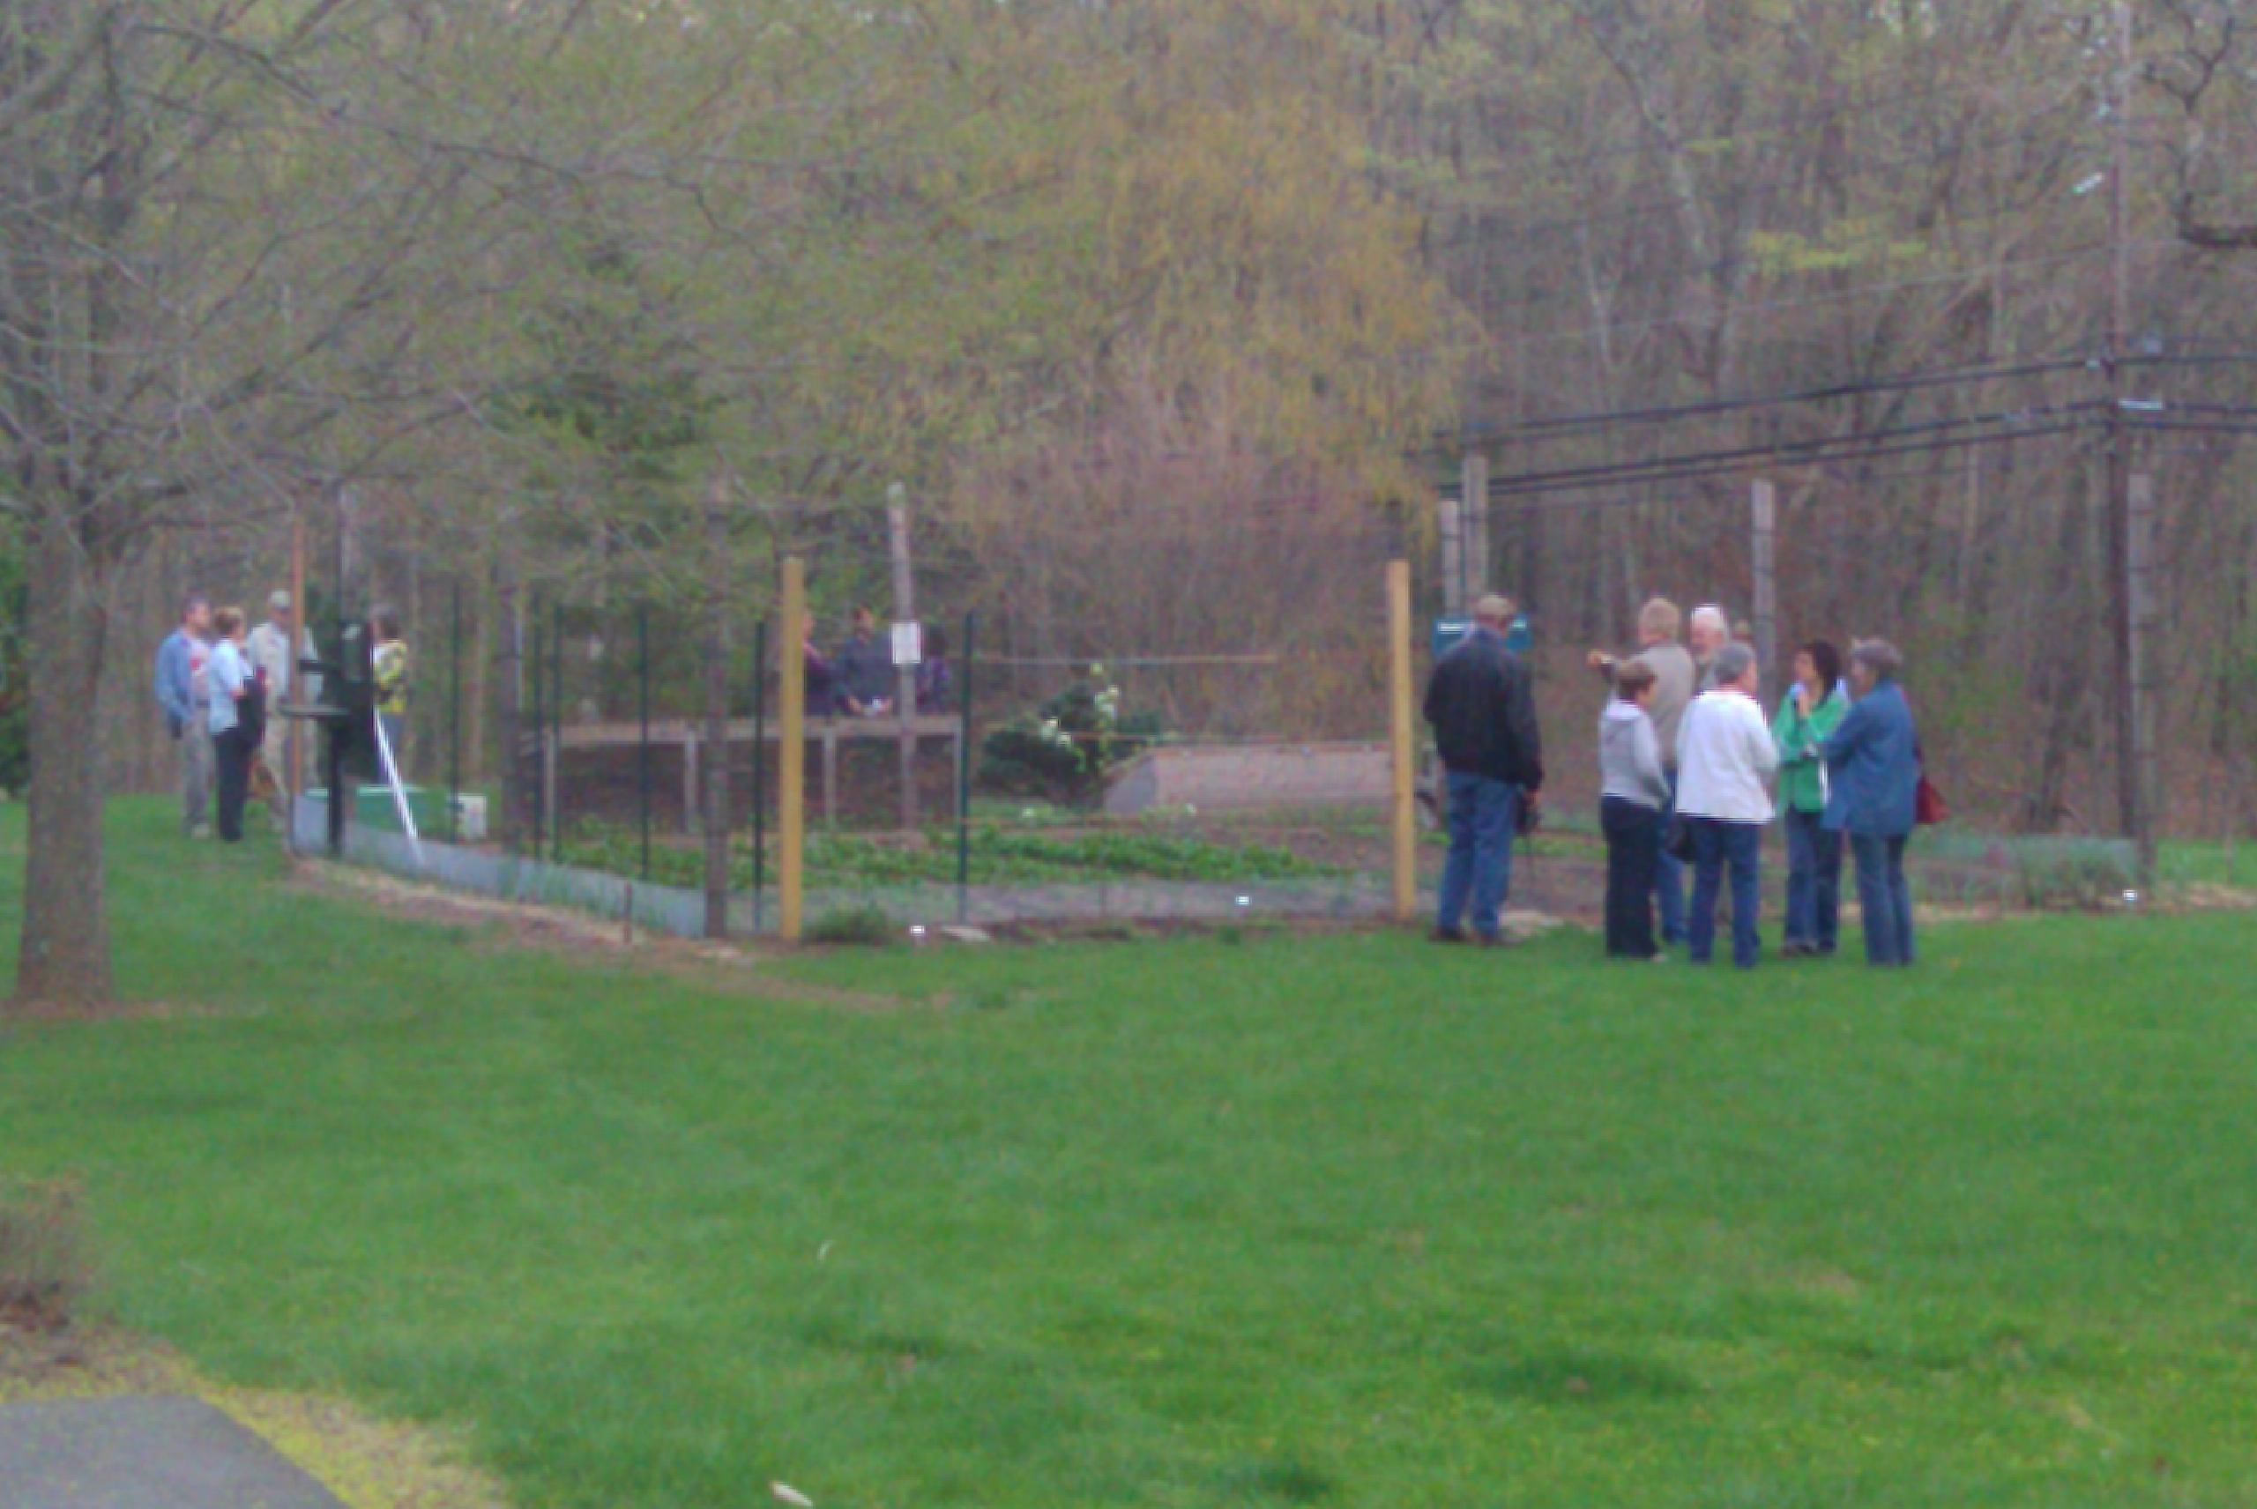

Submitted by,
Chantal Foster

