MG Community Garden Calendar
June-September 2011

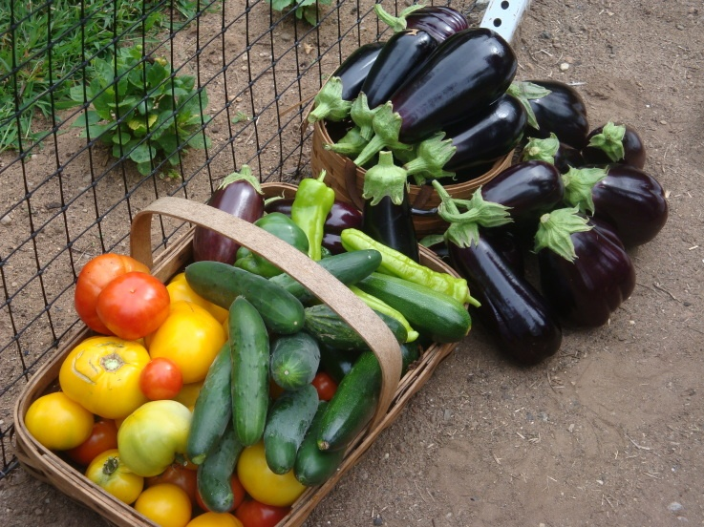

 | ~ June 2011 ~ |  |  |  |  | Jul 2011 ►
Sun | Mon | Tue | Wed | Thu | Fri | Sat
 |  |  | 1 | 2 | 3  JAMIE | 4
5  CHANTAL | 6 | 7  MAUREEN  TIM  Tad, Sherry, Karen | 8  JAMIE Water | 9  CHANTAL: Harvest and JAMIE water | 10  JAMIE: Water | 11
12 | 13  MARISA  Harvest | 14 | 15  KAREN: Harvest  Elizabeth Park Rose Garden Tour 6:30 pm | 16  PEGGY: Harvest | 17 | 18
19  Jamie: Harvest | 20  Jim | 21  MAUREEN | 22 | 23  Fern: Check on watering  KAREN: Harvest | 24  6:30 FOCUS GROUP | 25  Conn College Nature Tours 9am
26  Chantal | 27  Jim: Harvest | 28  TOM | 29  LOIS | 30 | Notes:  Mondays, Wednesdays, and Saturdays: Amazing Grace  Tuesdays, Thursdays and Fridays: St Vincent DePaul

 | ~ July 2011 ~ |  |  |  |  | Aug 2011 ►
Sun | Mon | Tue | Wed | Thu | Fri | Sat
 |  |  |  |  | 1  Chantal:Harvest | 2
3 | 4  HOLIDAY NO HARVEST DELIVERY | 5  Karen: Harvest | 6 | 7 | 8  Fern | 9
10 | 11  Lois | 12 | 13 | 14  Karen | 15  Susan | 16  CMGA Summer Garden Safari 9 am
17 | 18  Jim | 19  Marisa | 20  Peggy | 21  2:00 Boy Scouts Outreach (Susan and Karen) | 22  Susan | 23
24  Jamie | 25 | 26 | 27  Chantal | 28 | 29  6:30 Focus Group | 30
31 | Notes:  Mondays, Wednesdays, and Saturdays: Amazing Grace  Tuesdays, Thursdays and Fridays: St Vincent DePaul

 | ~ August 2011 ~ |  |  |  |  | Sep 2011 ►
Sun | Mon | Tue | Wed | Thu | Fri | Sat
 | 1  Jim | 2  Jim | 3  Lois | 4 | 5  Susan | 6
7 | 8 | 9  Peggy | 10 | 11  Karen | 12  Lois | 13
14 | 15 | 16  Maureen | 17 | 18  Karen | 19  Marisa | 20
21 | 22  Marisa | 23  TOM | 24 | 25  Peggy | 26  6:30 Focus Group | 27
28 | 29 | 30 | 31 | Notes:  Mondays, Wednesdays, and Saturdays: Amazing Grace  Tuesdays, Thursdays and Fridays: St Vincent DePaul

 | ~ September 2011 ~ |  |  |  |  | Oct 2011 ►
Sun | Mon | Tue | Wed | Thu | Fri | Sat
 | Mondays, Wednesdays, and Saturdays: Amazing Grace | Tuesdays, Thursdays and Fridays: St Vincent DePaul |  | 1 | 2 | 3
4 | 5  HOLIDAY NO HARVEST DELIVERY | 6 | 7 | 8 | 9 | 10
11 | 12 | 13 | 14 | 15 | 16 | 17
18 | 19 | 20 | 21 | 22 | 23 | 24
25 | 26 | 27 | 28 | 29 | 30  6:30 Focus Group | Notes:

 | ~ October 2011 ~ |  |  |  |  | Nov 2011 ►
Sun | Mon | Tue | Wed | Thu | Fri | Sat
 | Mondays, Wednesdays, and Saturdays: Amazing Grace | Tuesdays, Thursdays and Fridays: St Vincent DePaul |  |  |  | 1
2 | 3 | 4 | 5 | 6 | 7 | 8  GARDEN CLEANUP; SOW SPINACH, COLD FRAME
9 | 10 | 11 | 12 | 13 | 14 | 15
16 | 17 | 18 | 19 | 20 | 21 | 22
23 | 24 | 25 | 26 | 27 | 28  6:30 Focus Group | 29  CLOSE GARDEN, PLANT GARLIC
30 | 31 | Notes:

